SIMULATION EXPERIMENT
Simulation-Based Investigation of Microwave Semiconductor Devices and Frequency-Conversion Characteristics of a Microwave Mixer
1. Aim
To investigate the frequency-conversion characteristics of a microwave mixer using numerical simulation, with an RF input of 10 GHz, a local oscillator (LO) input of 9.5 GHz, and a 50 Ω intermediate-frequency (IF) load.
2. Objectives
- To configure the RF and LO frequencies and their input power levels.
- To calculate the intermediate frequency produced by mixing the RF and LO signals.
- To estimate the idealized sum- and difference-frequency components.
- To observe how mixer conversion loss and output power relate to the selected input conditions.
3. Input Parameters
S. No. | Input parameter | Symbol / setting | Value to enter | Unit
1 | RF frequency | fRF | 10 | GHz
2 | LO frequency | fLO | 9.5 | GHz
3 | RF input power | PRF | −10 | dBm
4 | LO power | PLO | +7 | dBm
5 | IF load impedance | ZIF | 50 | Ω
4. Theory
A microwave mixer is a nonlinear semiconductor circuit that combines a radio-frequency (RF) signal with a local-oscillator (LO) signal to produce new frequency components. The principal components occur at the sum and difference of the input frequencies: fSUM = fRF + fLO and fIF = |fRF − fLO|. For fRF = 10 GHz and fLO = 9.5 GHz, the difference frequency is 0.5 GHz (500 MHz), and the sum frequency is 19.5 GHz. The 500 MHz difference component is commonly selected as the intermediate frequency (IF).
The given input powers and 50 Ω IF load are simulation settings. Actual IF output power cannot be determined from these settings alone because it depends on the mixer topology, semiconductor model, conversion loss, matching networks, and parasitic effects. The MATLAB/Octave example below uses a clearly stated illustrative conversion-loss assumption of 6 dB to estimate an IF output power; replace this value with the mixer datasheet value or the result from a circuit/EM simulator.
5. Procedure
- Open MATLAB or GNU Octave and create a new script file.
- Enter the RF frequency, LO frequency, RF input power, LO power, and IF load impedance.
- Calculate the difference frequency and sum frequency using the mixer frequency-conversion equations.
- Set an illustrative conversion loss (6 dB in this example) for an initial estimate of the IF output power.
- Convert the RF input power from dBm to milliwatts and estimate the IF power using the assumed conversion loss.
- Run the script and record the IF frequency, sum frequency, estimated IF output power, and voltage across the 50 Ω load.
- For realistic device characterization, replace the illustrative loss with a semiconductor mixer model or datasheet value and simulate the circuit in an RF tool such as ADS, AWR, or an equivalent simulator.
6. MATLAB / GNU Octave Code
clc;
clear;
close all;

% Given Parameters
fRF = 10e9;
fLO = 9.5e9;
PRF = -10;
PLO = 7;
ZIF = 50;

% Frequency Conversion
fIF = abs(fRF-fLO);
fSUM = fRF+fLO;

% Conversion Loss
CL = 7;
PIF = PRF-CL;

% Display Results
fprintf('MICROWAVE MIXER RESULTS\n');
fprintf('RF Frequency = %.2f GHz\n',fRF/1e9);
fprintf('LO Frequency = %.2f GHz\n',fLO/1e9);
fprintf('IF Frequency = %.2f GHz\n',fIF/1e9);
fprintf('Sum Frequency = %.2f GHz\n',fSUM/1e9);
fprintf('IF Output Power = %.2f dBm\n',PIF);
fprintf('Conversion Loss = %.2f dB\n',CL);

% Generate Signals
fs = 100e9;
t = 0:1/fs:20e-9;

RF = cos(2*pi*fRF*t);
LO = cos(2*pi*fLO*t);

% Mixer Output
Mixer = RF.*LO;

% Frequency Spectrum
N = length(Mixer);
Y = abs(fft(Mixer));
F = (0:N-1)*fs/N;

% Plot Frequency Spectrum
figure;
plot(F/1e9,Y,'LineWidth',1.5);
xlim([0 25]);
grid on;

xlabel('Frequency (GHz)');
ylabel('Magnitude');
title('Microwave Mixer Frequency Spectrum');
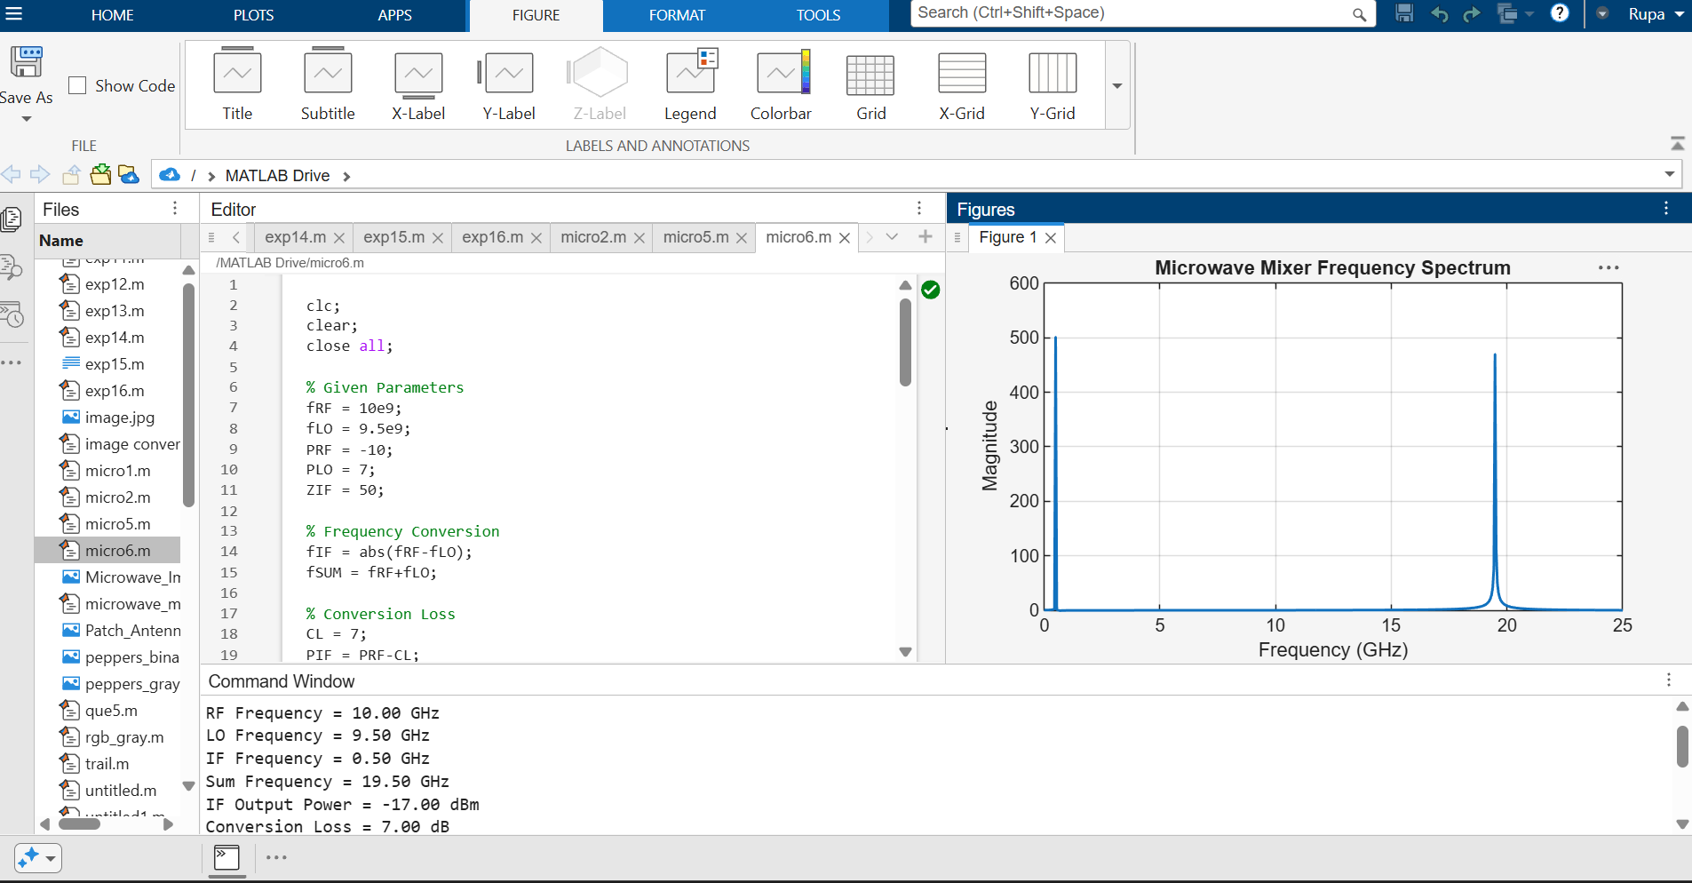

7. Output Parameters
S. No. | Output parameter | Symbol / formula | Expected value | Unit
1 | Intermediate frequency | fIF = |fRF − fLO| | 0.5 | GHz
2 | Sum frequency | fSUM = fRF + fLO | 19.5 | GHz
3 | RF input power | PRF | −10 | dBm
4 | LO power | PLO | +7 | dBm
5 | Assumed conversion loss | CL | 6 (illustrative assumption) | dB
6 | Estimated IF output power | PIF = PRF − CL | −16 (under stated assumption) | dBm
7 | Estimated IF output power | PIF | 0.0251 (under stated assumption) | mW
8 | IF load voltage (RMS) | √(PIF × ZIF) | ≈ 0.0354 (under stated assumption) | V
8. Expected Observations
The mixer produces a difference-frequency component at 0.5 GHz and a sum-frequency component at 19.5 GHz. The 0.5 GHz component is selected as the IF output. In this example, the IF power estimate is −16 dBm only because a 6 dB conversion loss has been assumed. The actual output level must be obtained from the chosen mixer model or device specifications.
9. Result
The numerical calculation gives an intermediate frequency of 0.5 GHz (500 MHz) and a sum frequency of 19.5 GHz for RF = 10 GHz and LO = 9.5 GHz. With an illustrative 6 dB conversion-loss assumption, the estimated IF output is −16 dBm (approximately 0.0251 mW) into a 50 Ω load. This power is an estimate, not a measured or validated device-simulation result.

10. Conclusion
The simulation demonstrates the basic frequency-conversion principle of a microwave mixer. The difference between the RF and LO frequencies determines the IF frequency, while the actual IF output power depends on the selected semiconductor device, its conversion loss, matching, and operating conditions.

